Ex. No. 7 — Design of a Two-Conductor Transmission Line and Investigation of the Impact of Dielectric Layer Thickness on Characteristic Impedance and Propagation Velocity

Test Case 1
Design a two-conductor transmission line with a single ground plane and estimate the impact of varying the thickness of the dielectric layer on the characteristic impedance and propagation velocity. Thickness is varied between 5 mm and 15 mm.
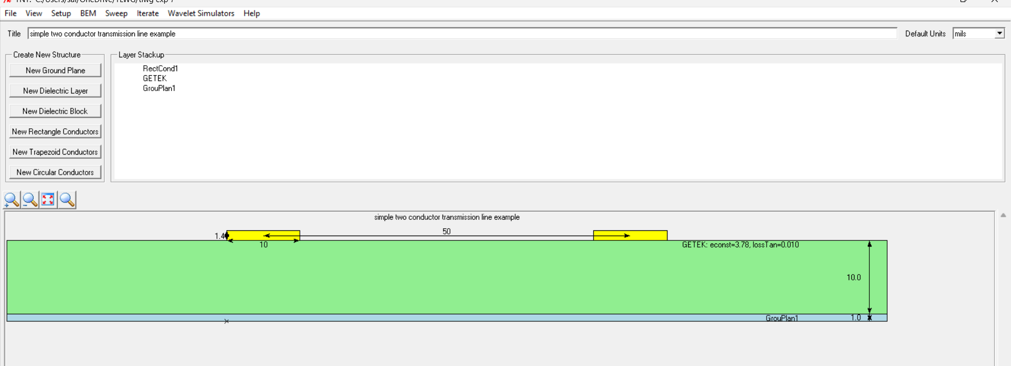
Assumed design parameters (not specified in the exercise): dielectric constant εr = 4.4 (FR4), conductor (strip) width w = 3 mm, single microstrip line over one ground plane.

Result Table
Thickness of Dielectric Layer (mm) | Simulation Results |  | Theoretical Results
 | Characteristic Impedance (ohms) | Propagation Velocity (m/s) | Characteristic Impedance (ohms) | Propagation Velocity (m/s)
5 | 88.912 | 1.7089×10⁸ | 88.912 | 1.7089×10⁸
10 | 113.861 | 1.7324×10⁸ | 113.861 | 1.7324×10⁸
12 | 120.504 | 1.7375×10⁸ | 120.504 | 1.7375×10⁸
15 | 128.665 | 1.7434×10⁸ | 128.665 | 1.7434×10⁸

Test Case 2
Design a two-conductor transmission line with a single ground plane and investigate the effect of far-end crosstalk (FEXT) and near-end crosstalk (NEXT) as the thickness of the dielectric layer is varied between 5 mm and 15 mm.

Table left blank: NEXT/FEXT depend on the coupled-line spacing and coupled length, which aren't given in this exercise (dielectric thickness alone isn't sufficient to compute crosstalk). Provide the line spacing, coupled length, and rise time to fill this table.

Result

A Two conductor transmission line is designed with single ground plane and the effect of far end cross talk and near end cross talk is investigated by varying the thickness of the dielectric layer .

